Project Evolve
System - Atradius Experience

User Interface Design Specification

Nov 26, 2015
Ver 0.3

In association with:

Document History

Version | Change Description | Author | Date Released
0.1 | Initial Document | Infosys | 05/05/2004
0.2 | Modified to fit Atradius Experience, added details for risk screen | Jonathan Elsen | 25/11/2015
0.3 | Add ranking page documentation | Jonathan Elsen | 26/11/2015
0.4 | Added login and wrapper screens | Emanuel | 27/11/2015

Table of Contents
1 Wrapper 5
1.1 Description 5
1.2 Screen Layout 5
1.3 Screen Element Specification 7
1.4 Validation, Business Rules, Dynamic Specifications 7
1.5 Pop Ups (avatar) 8
1.6 Pull Downs 9
1.7 Warnings and Exceptions 11
1.8 Issues 12
2 Login screen 13
2.1 Description 13
2.2 Screen Layout 13
2.3 Screen Element Specification 14
2.4 Validation, Business Rules, Dynamic Specifications 14
2.5 Warnings and Exceptions 14
3 Risk screen 15
3.1 Description 15
3.2 Screen Layout 15
3.3 Screen Element Specification 16
3.4 Validation, Business Rules, Dynamic Specifications 17
3.5 Tab Order 18
3.6 Pop Ups 18
3.7 Pull Downs 19
3.8 Warnings and Exceptions 19
3.9 Issues 19
4 Ranking screen 20
4.1 Description 20
4.2 Screen Layout 20
4.3 Screen Element Specification 21
4.4 Validation, Business Rules, Dynamic Specifications 21
4.5 Tab Order 21
4.6 Pop Ups 22
4.7 Pull Downs 22
4.8 Warnings and Exceptions 22
4.9 Issues 22
5 Appendix 23

Wrapper

Description
This screen functions as a content wrapper. It includes the navigation menu and additional user features such as loggin out, displaying team info and (mini) dashboard to indicate team performance.

Screen Layout
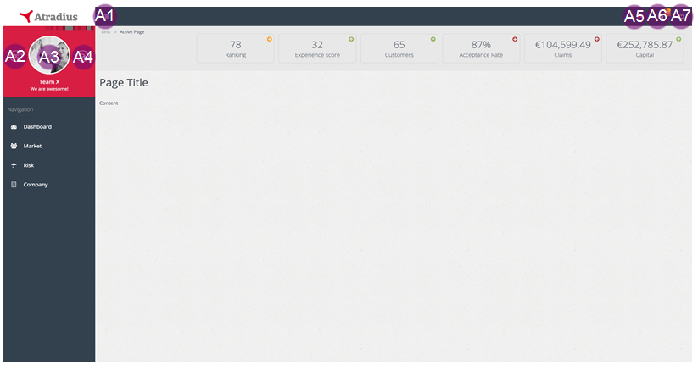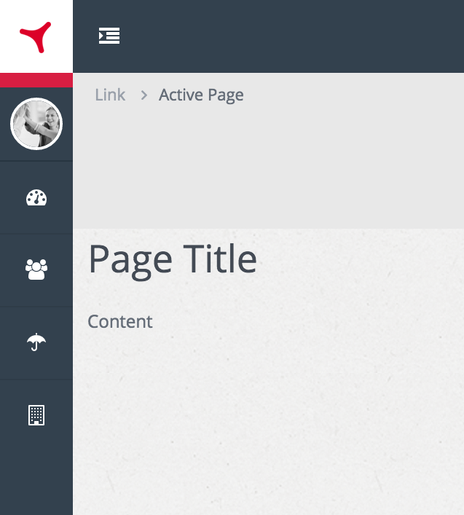
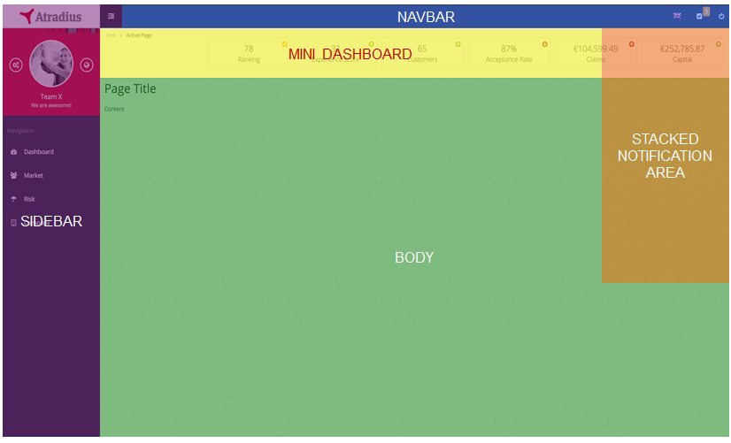
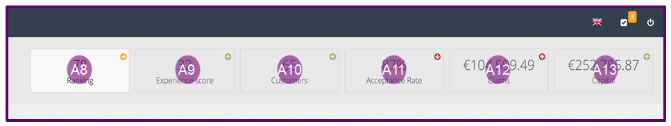

Screen Element Specification
Ele ID# | Dynamic/Static | Element Name | Element Type | Default State | Action | Response/ Notes
Block A – short description
A1 | Dynamic | collapseSidebar | Hyperlink | Disabled | Collapse entire sidebar towards the left with CSS/Javascript on the front-end | Images like logo and avatar need to be made smaller as the sidebar will remain visible
A2 | Dynamic | /settings | Hyperlink | Disabled | Loads ‘settings’ content | None
A3 | Dynamic | uploadAvatar | Hyperlink | Disabled | Opens OS selection window | After image selection, the image is displayed immediately in the avatar position after upload
A4 | Dynamic | /ranking | Hyperlink | Disabled | Loads ‘ranking’ content | None

Validation, Business Rules, Dynamic Specifications
ID# | Event | Business logic
A1 | OnClick | None
A2 | OnClick | Ui-router redraws BODY with the ‘settings’ content
A3 | OnClick | Open OS file selection window, after submit upload the image to the server and store it in the ‘team’ collection. Then load it in the avatar placeholder.
A4 | OnClick | Ui-router redraws BODY with the ‘ranking’ content

ID# | Scenario | Validation | Notify user type | Alert (Error) text
A3 | If user attempts to upload a non-image file | Check if non-image file is selected for upload | Error | The selected file is not an image. Please select an image file like JPG or PNG.
A3 | If user attempts to upload a file with a greater than 500px by 500px dimension | Check if image has bigger dimensions than 500px | Error | Your image is to big. Please make your image smaller so that we can upload the file to your profile.
A3 | If user attempts to upload a file larger than 500kb | Check if image is below 500kb in size | Error | Your image is too heavy. Please make sure the image size is below 500kb. Perhaps you can make your image smaller.
A3 | When system has successfully replaced the previous (default) avatar with the newly uploaded image | When image is successfully uploaded and replaced | Success | You successfully uploaded your team avatar!

Pop Ups (avatar)
ID# | Dynamic/Static | Element Name | Element Type | Default state | Action | Response/ Notes
Block A – short description
A3 | Dynamic | uploadAvatar | Hyperlink | Disabled | Opens OS selection window | After image selection, the image is displayed immediately in the avatar position after upload

Pull Downs
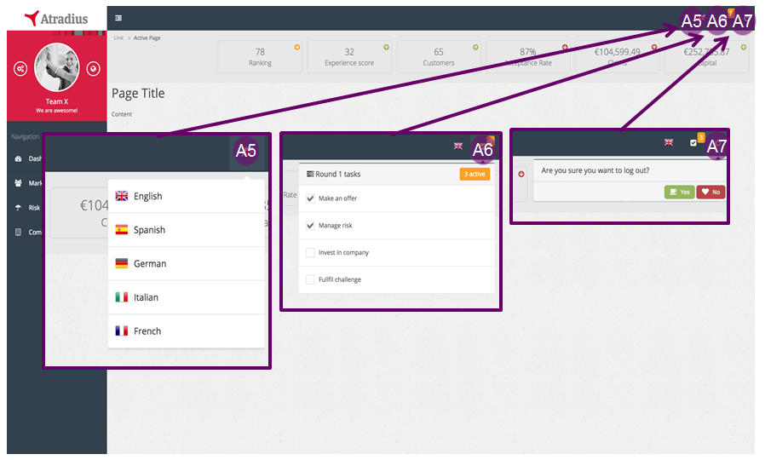
ID# | Dynamic/Static | Element Name | Element Type | Default state | Action | Response/ Notes
Block A – short description
A5 | Dynamic | languageSettings | Hyperlink | Disabled | Navbar dropdown opens languages dialog | Selected language is not in the dropdown. All content need to be ready for localization
A6 | Dynamic | activityList | Hyperlink | Disabled | Navbar dropdown opens activity list | User can not interact with the items in the activity list. The list is a fixed set of actions that the user have to accomplish in the respective round. Each round the activity list resets  Has icon notification, showing the amount of outstanding activities left undone (unchecked)
A7 | Dynamic | logoutDecision | Hyperlink | Disabled | Navbar dropdown opens logout dialog | The user can select ‘yes’ (to log user out of its session) or ‘no’ to cancel the dialog. If ‘no’ is selected, dialog box gets disabled (disappears)

ID# | Event | Business logic
A5 | OnClick & ‘language selection’ | Switch localization to the user’s selection which changes the entire text to the specific language and updates the respective page (replacing previous text with new text)
A6 | OnClick & ‘activity list dropdown’ | Dropdown the activity list with all activities displayed for each round. The activities that are outstanding are determined by whether certain actions haven’t happened yet. With every new round, set below elements to false (unchecked) and then set it to true every time an activity takes place (so it will be left as checked).  - Manage risk -> check if team has set a risk strategy on the Risk Page  - Make an offer -> check if team has made an offer on the Market Page  - Invest in company -> check if team has made an investment on the Company Page  - Fulfil challenge -> check if team has accomplished this round’s challenge (TBD)
A7 | OnClick & ‘yes’ | Log user out of its session
A8 | Load ranking number | After every round’s recalculation, teams need to be assigned a rank in comparison with other teams based on how much capital they own (i.e. team with highest capital is ranked 1). On page load – except login & error pages – current & previous round’s team rank is retrieved to display the rank and whether to display and up, right or down coloured icon.
A9
A10 | Premium (not Acceptance Rate)

Warnings and Exceptions
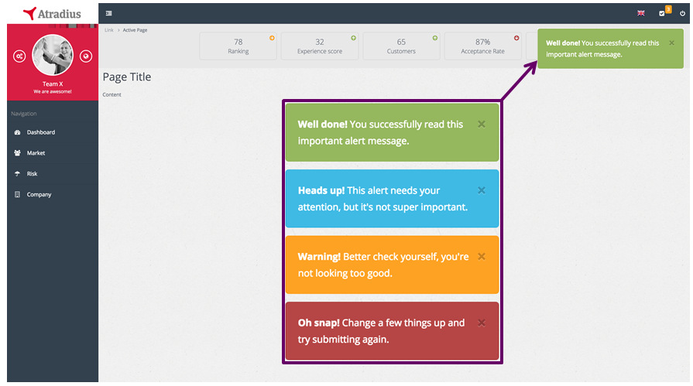

ID# | Dynamic/Static | Element Name | Element Type | Default state | Action | Response/ Notes
Alerts – alert notifications that will be defined in each screen
Alert | Dynamic | notifyer | Div tag | Disabled | Only pops up when the system pushes a message to the client (e.g. when user accomplished a specific activity)  If multiple messages have been pushed from the server, then the message will stack on top of each other with the newest on top | We used ‘toastr’ package that can easily be incorporated when certain conditions apply (front-end rendering comes included). These messages need to be localized  Implementation:  toastr.success(‘title’, ‘msg’);  toastr.info(‘title’, ‘msg’);  toastr.error(‘title’, ‘msg’);  Package:  https://github.com/Foxandxss/angular-toastr

Issues
Todo: Breadcrumb, Title/Slogan & Sidebar navigation

Login screen

Description
This screen only displays login credentials (email, password) and a button to login. The colouring is not so important yet but you can use #DC0028. Later on we can provide the exact CSS styles

Screen Layout
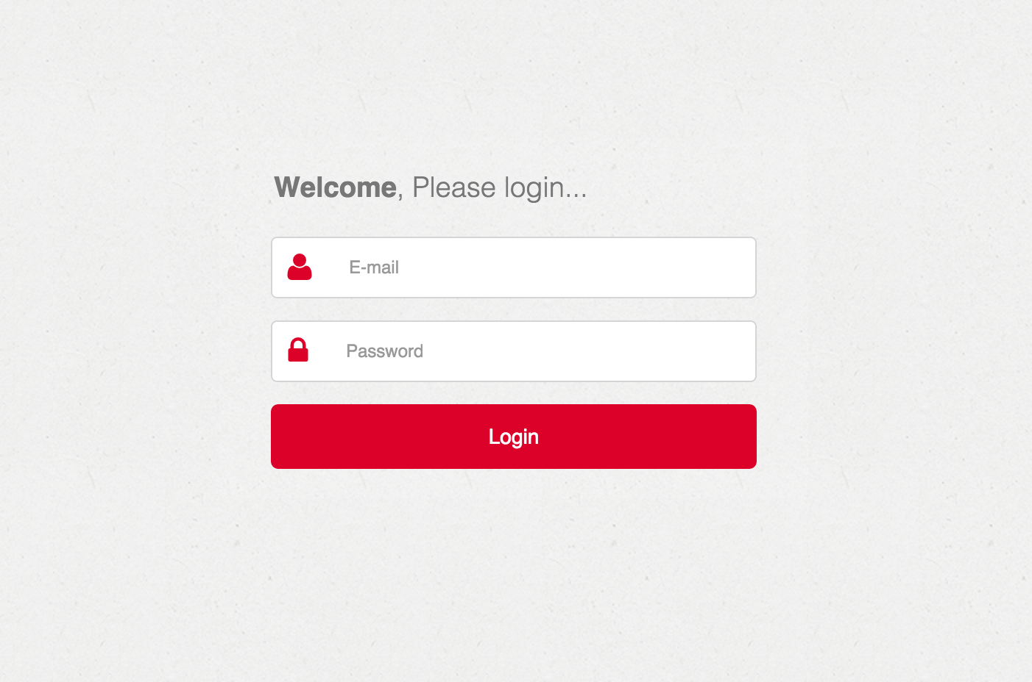

Screen Element Specification
ID# | Dynamic/Static | Element Name | Element Type | Default state | Action | Response/ Notes
Block A – short description
A1 | Dynamic | email address | Input | Active
A2 | Dynamic | Password | Input | Disabled

Validation, Business Rules, Dynamic Specifications
ID# | Event | Business logic
A1 | Username not recognized | Display inline error in red text below the button
A2 | Password not matching account | Display inline error in red text below the button

Warnings and Exceptions
…

Risk screen

Description
This screen displays the risk strategies that the team has set up. Initially this will be unpopulated, until teams create strategies, which they do by clicking on the button ‘Add New Strategy’. When they do this, a modal popup appears for them to enter the details of the strategy. Once they have created these details, the table is populated with the strategy. They also have the ability to modify or delete already existing strategies.

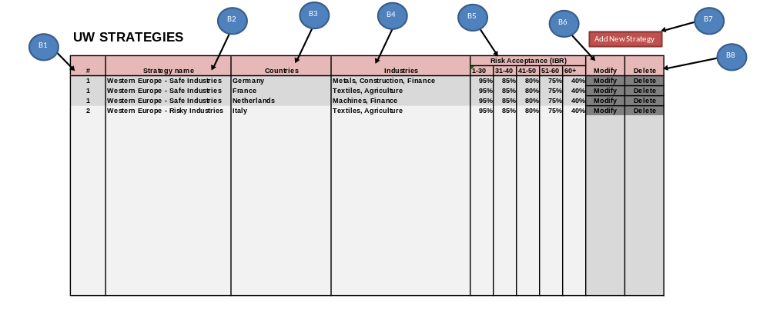
Screen Layout

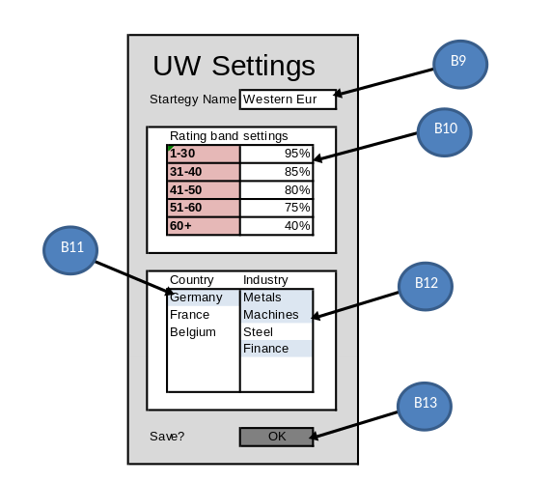

Page Invocation:

Screen | Action
UW Strategies | Click on “Risk” on sidebar. Main screen area changes to the Risk HTML.
UW Settings | Click on “Add new strategy”. Modal popup with strategy input fields appears.

Page Authorization:

User/Group | Authorization
Everyone | Full

Screen Element Specification
Ele ID# | Dynamic/Static | Element Name | Element Type | Default State | Action | Response/ Notes
UW Strategies Screen
B1 | Dynamic | ID | Table data | Shows strategy number | is always refreshed with current data | unique id
B2 | Dynamic | Strategy name | Table data | Shows strategy name | is always refreshed with current data
B3 | Dynamic | Countries | Table data | Shows strategy country | is always refreshed with current data
B4 | Dynamic | Industries | Table data | Shows strategy industries of the country | is always refreshed with current data
B5 | Dynamic | Risk Acceptance | Table data | Shows risk acceptance settings | is always refreshed with current data
B6 | Dynamic | Modify strategy | Button | Visible/Clickable | Opens uw strategy screen with data for selected strategy | user can modify strategy
B7 | Dynamic | Add strategy | Button | Visible/Clickable | Opens uw strategy screen with empty data fields | user can add strategy
B8 | Dynamic | Delete strategy | Button | Visible/Clickable | Removes Strategy | should be a confirmation box popup

Ele ID# | Dynamic/Static | Element Name | Element Type | Default State | Action | Response/ Notes
UW Settings popup
B9 | Dynamic | Strategy name input | User input | if new strategy then null, if modify then prefilled | Enter text | This is just so the user can give a name to a strategy
B10 | Dynamic | Risk Acceptance input | User input | if new strategy then null, if modify then prefilled | Enter risk acceptance rate
B11 | Dynamic | Country selection | List box | unselected if new, if modify then preselected | on click - select/unselect
B12 | Dynamic | Industry selection | List box | unselected if new, if modify then preselected | on click - select/unselect | industries are those connected to country
B13 | Dynamic | Save | Button | Visible/Clickable | saves data for strategy

Validation, Business Rules, Dynamic Specifications
Screen Element ID | Screen Name | Field level  Validations | Business Rule, Dynamic Specification
B1 | Strategy ID |  | Background colour two tone, to help separate strategies visually.
B2 | Strategy name
B3 | Countries
B4 | Industries
B5 | Risk Acceptance
B6 | Modify strategy
B7 | Add strategy
B8 | Delete strategy | Confirmation required
B9 | Strategy name input | Limited to 30 char
B10 | Risk Acceptance input | Must be percentage 0-100
B11 | Country selection | List box with options. | Countries grouped by regions.  Single selection to start (possibly find solution to make multi select).
B12 | Industry selection | List box with options | Industries of countries without a strategy available. Country-Industry combinations with strategy already show greyed out  Multi-selection
B13 | Save | Confirmation required

Tab Order
# | Element/ID (From) | Element/ID (To)
 | A7 | A7

Pop Ups
# | Element ID | Action | Pop Up Information

Pull Downs
# | Element ID | Pull down Options | Source Table/Listing

Warnings and Exceptions

Element Id | Scenario | Message Text/Box | Error/ Warning/  Information | Message Text | Existing/  New

Issues
Issue# | Issue | Resolution

Ranking screen

Description
This section details the ranking screen. This screen is comprised of four tables. The two left tables show the overall ranking, first by capital, and then by experience score. The two right tables show the ranking within the team’s country. In the example shown below, this is NL. The same tables are shown as for the overall ranking, with the exception of the country field. The ranking is not a full ranking, only a snapshot of their section of the ranking along with two teams above and below.

Screen Layout
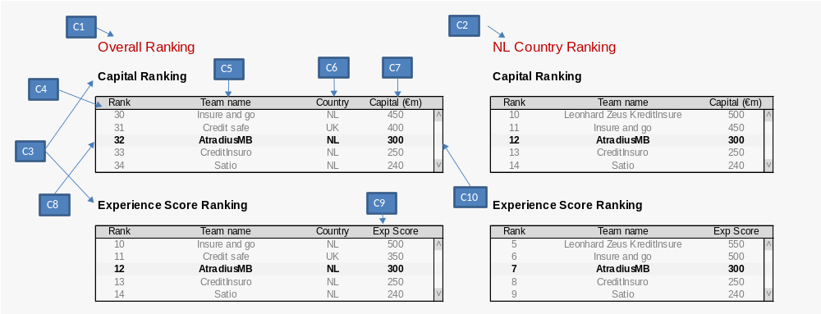

Screen Element Specification
Ele ID# | Dynamic/Static | Element Name | Element Type | Default State | Action | Response/ Notes
Ranking Screen
C1 | Static | Overall Heading | Label | “Overall Ranking” | None
C2 | Dynamic | Country Heading | Label | [Country Name] & “ Country Ranking” | None | Text varies depending on country of team.
C3 | Static | Table Heading | Label | Contains title of table | None
C4 | Dynamic | Rank field | Table field | Displays rank of team | None
C5 | Dynamic | Team name field | Table field | Displays name of team | None
C6 | Dynamic | Country field | Table field | Displays country of team | None
C7 | Dynamic | Capital field | Table field | Displays capital of team | None
C8 | Dynamic | Teams own row | Table row | This row is the details of the team that is logged in. It is bolder than the other teams in the table | Takes user to team dashboard
C9 | Dynamic | ExpScore field | Table field | Displays ExpScore of team | On mouse over, displays caption explaining what this score is.
C10 | Dynamic | Table Scrollbar | Scrollbar | As required to focus on team | Scrolls

Validation, Business Rules, Dynamic Specifications

Tab Order

Pop Ups

Pull Downs

Warnings and Exceptions

Issues

Appendix

